H.T No
Regulations:
A19

Sreenidhi Institute of Science and Technology
(An Autonomous Institution)
Code No: 7R103 Date: 14-July-2021 (FN)

M.Tech I-Year I-Semester External Examination, July - 2021 (Regular & Supplementary)
ADVANCED COMPUTER NETWORKS (CNIS)

Time: 3 Hours Max.Marks:70

Note: a) No additional answer sheets will be provided.
b) All sub-parts of a question must be answered at one place only, otherwise it will not be valued.
c) Missing data can be assumed suitably.

ANSWER ANY 5 OUT OF 8 QUESTIONS. EACH QUESTION CARRIES 14 MARKS.

Bloom's Cognitive Levels of Learning (BCLL)

Remember | L1 | Apply | L3 | Evaluate | L5
Understand | L2 | Analyze | L4 | Create | L6

 |  |  | BCLL | CO(s) | Marks
1. | a) | Explain the concept of Encapsulation used in Protocol layers. | L1 | CO1 | [7M]
 | b) | Discuss about the Internet Protocol (IP) Packet format in detail. | L2 | CO1 | [7M]
2. | a) | Discuss the Checksumming method of Error Detection in detail. | L3 | CO2 | [7M]
 | b) | Explain the frame structure of Ethernet LAN in detail. | L2 | CO2 | [7M]
3. | a) | Determine the least-cost path from node A to node B in the figure below Using Dijkstra's algorithm:  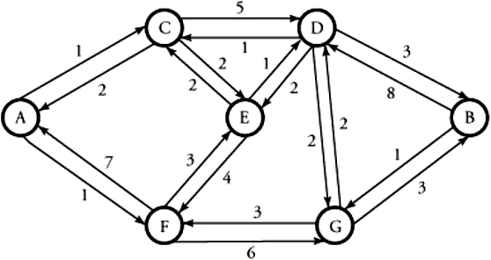 | L4 | CO3 | [7M]
 | b) | Explain about the Unidirectional and Bidirectional Congestion control in Network Layer. | L3 | CO3 | [7M]
4. | a) | Compare the logical addressing scheme of IPv4 with IPv6. | L5 | CO4 | [7M]
 | b) | Explain HTTP with Non-Persistent and Persistent connection. | L2 | CO4 | [7M]
5. | a) | Discuss about Infrared LANs and Spread-Spectrum LANs used in Wireless Technologies. | L2 | CO5 | [7M]
 | b) | Explain the classification of routing protocols in Mobile Ad-hoc networks. | L3 | CO5 | [7M]
6. | a) | Describe how the routing is executed in Multiprotocol Label switching? | L3 | CO6 | [7M]
 | b) | Discuss about Quality of service in VoIP. | L4 | CO6 | [7M]
7. | a) | Discuss about Queuing delay. | L1 | CO1 | [5M]
 | b) | Write briefly about the Slotted Aloha Protocol. | L3 | CO2 | [5M]
 | c) | Write about Border gateway protocol. | L2 | CO3 | [4M]
8. | a) | Appraise the TCP services in transport services provided by the internet. | L4 | CO4 | [5M]
 | b) | Discuss about Protocol Stack in Wireless sensor networks. | L5 | CO5 | [5M]
 | c) | Specify the MPLS header encapsulation format for an IP packet. | L6 | CO6 | [4M]

-- 00 -- 00 –

